|  |
| --- |
|  |
| Capstone Project Document |

**FIRST AID**

Report #1 - User Requirement Specification

|  |  |  |
| --- | --- | --- |
| **First Aid** | | |
| **Group Members** | Đàm Huy Hùng | SE03431 |
| Nguyễn Duy Anh | 01525 |
| Mai Trung Kiên | SE02994 |
| Nguyễn Tiến Dũng | SE03272 |
| Nguyễn Phúc An | SE03118 |
| **Supervisor** | Mr. Nguyễn Văn Sang | |
| **Project code** | FAVN | |

**- Hanoi, 09/2016 –**

# SIGNATURE PAGE

AUTHOR: Nguyễn Duy Anh 16/09/2016

Team member

REVIEWERS: Đàm Huy Hùng 21/09/2016

Project manager

APPROVAL: Nguyễn Văn Sang --/--/--16

Supervisor

Record of change

*A - Added M - Modified D – Deleted

|  |  |  |  |  |  |
| --- | --- | --- | --- | --- | --- |
| Effective Date | Changed Item | A,M,D | Change Description | Reason for Change | Rev. Number |
| 16/Sep/2015 | Create User Requirement Specification | A | First version | Create User Requirement Specification | 1.0 |
| 19/Sep/2015 | Create User Requirement Specification | M | First version | Update and modify more information | 1.0 |
|  |  |  |  |  |  |
|  |  |  |  |  |  |
|  |  |  |  |  |  |
|  |  |  |  |  |  |

Table Contents

SIGNATURE PAGE 1

1 USER REQUIREMENTS SPECIFICATION 3

1.1 Introduction 3

1.1.1 Purpose 3

1.1.2 Definition and Acronyms 3

1.2 Overall Description 3

1.2.1 Business Process Overview 3

1.2.2 Product Features 16

1.2.3 User characteristic 17

1.3 Functional Requirements 18

1.3.1 Common Function 18

1.3.2 Discover Projects 18

1.3.3 Create Project 18

1.3.4 Back Project 18

1.3.5 Send/Receive messages 18

1.3.6 Management profile 18

1.3.7 Management Member’s account 19

1.3.8 Management Project 19

1.3.9 Management Dashboard Overview 19

1.4 Non-functional Requirement 19

# USER REQUIREMENTS SPECIFICATION

## Introduction

### Purpose

This document will provide the describing of general requirement and non-functional requirements of our DDL system. It also describes the requirement scope of each phase in the project.

### Definition and Acronyms

|  |  |
| --- | --- |
| Terms | Description |
| FAS | First Aid system |
| FAA | First Aid application |
|  |  |

Table 1‑1: Definition and Acronyms

## Overall Description

### Business Process Overview

#### Approve/Suspend workflow

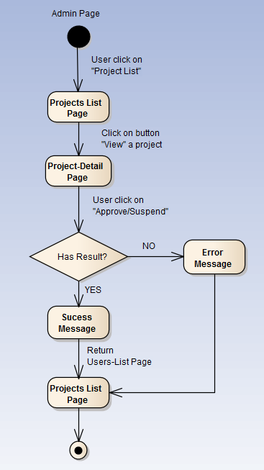

Figure 1‑1: Approve/Suspend workflow

Brief description: Admin can use this function. Steps:

* Step 1: User click on projects list.
* Step 2: System return projects list page.
* Step 3: User click on button view
* Step 4: System return project detail page.
* Step 5: User click on button Approved/Suspended
* Step 6: System return success message or error message.
* Step 7: System return projects list page.

#### Active/Inactive workflow

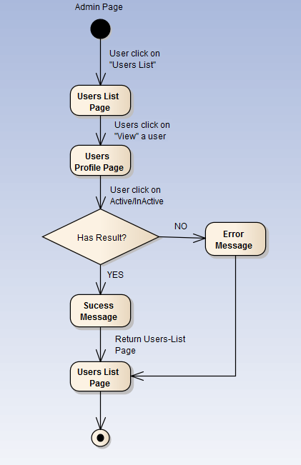

Figure 1‑2: Active/Inactive workflow

Brief description: Admin can use this function. Steps:

* Step 1: User click on users list.
* Step 2: System return users list page.
* Step 3: User click on button view a user
* Step 4: System return user profile page.
* Step 5: User click on button Active/Inactive
* Step 6: System return success message or error message.
* Step 7: System return users list page.

#### Add category workflow

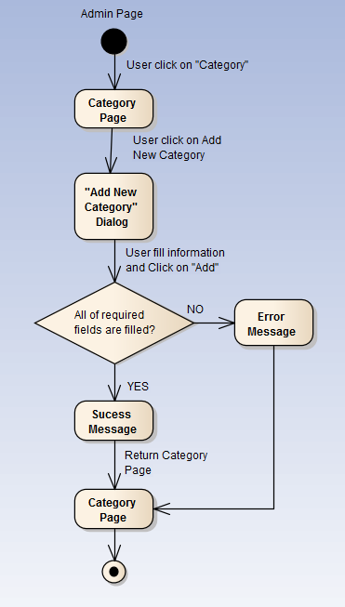

Figure 1‑3: Add category workflow

Brief description: Admin can use this function. Steps:

* Step 1: User click on Category.
* Step 2: System return category page.
* Step 3: User click on button new category
* Step 4: System return dialog “Add New Category”.
* Step 5: User fill information and click “Add”
* Step 6: System return success message or error message.
* Step 7: System return category page.

#### Add slider workflow

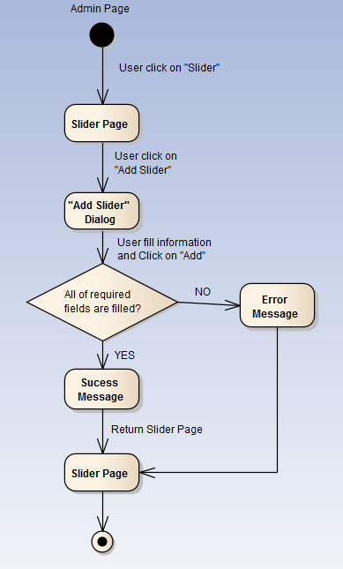

Figure 1‑4: Add slider workflow

Brief description: Admin can use this function. Steps:

* Step 1: User click on Slider.
* Step 2: System return slider page.
* Step 3: User click on button new slider.
* Step 4: System return dialog “Add New Slider”.
* Step 5: User fill information and click “Add”
* Step 6: System return success message or error message.
* Step 7: System return slider page.

#### Sent message workflow

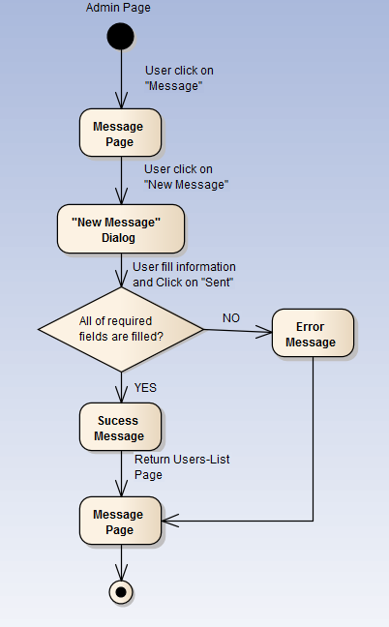

Figure 1‑5: Sent message workflow

Brief description: Admin or user can use this function. Steps:

* Step 1: User click on Message.
* Step 2: System return message page.
* Step 3: User click on “new message” button.
* Step 4: System return dialog “New Message”.
* Step 5: User fill information and click “Sent”
* Step 6: System return success message or error message.
* Step 7: System return message page.

#### Register workflow

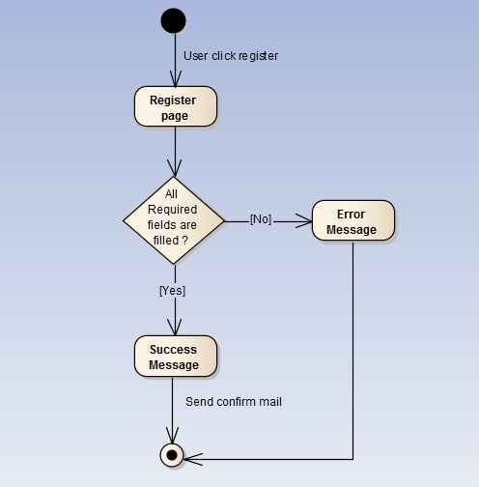

Figure 1‑6: Register workflow

Brief description: Guest can use this function. Steps:

* Step 1: User click register.
* Step 2: System return register page.
* Step 3: User fill all required fields and click Register or press Enter.
* Step 4: System return complete message.
* Step 5: System send confirm mail to user’s entered email.

#### Search workflow

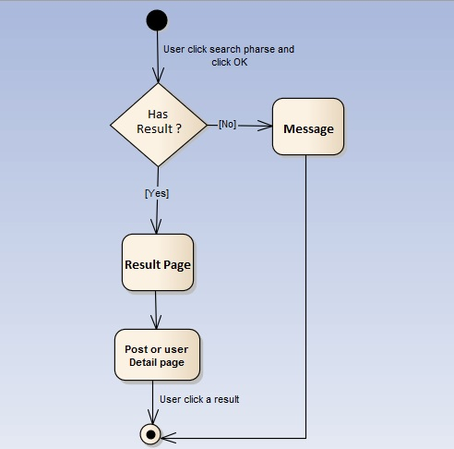

Figure 1‑7: Search workflow

Brief description: Guest and Member can use this function. Steps:

* Step 1: User input keyword into search text box and click Search or press Enter
* Step 2: System return search results or message if nothing found.
* Step 3: User can click returned results to view.

#### Comment workflow

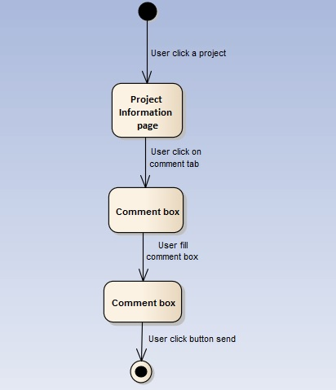

Figure 1‑8: Comment workflow

Brief description: Member can use this function. Steps:

* Step 1: User click on a project.
* Step 2: System return Project information page.
* Step 3: User click on comment tab.
* Step 4: System show comment tab.
* Step 5: User fill comment box.
* Step 6: User click sent.

#### Back a project workflow

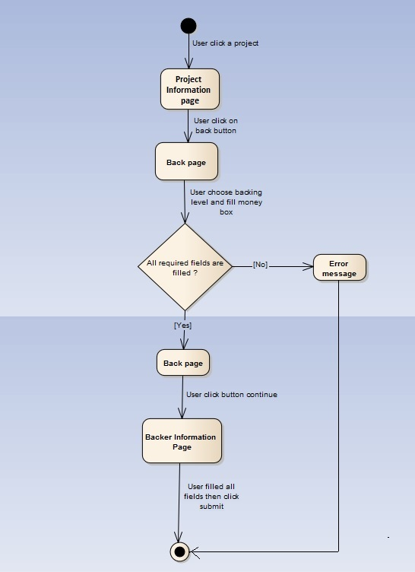

Figure 1‑9: Back a project workflow

Brief description: Guest and Member can use this function. Steps:

* Step 1: User click on a project.
* Step 2: System return Project information page.
* Step 3: User click on button back.
* Step 4: System return Back page.
* Step 5: User choose back level then click continue.
* Step 6: System return Backer information page.
* Step 7: User fill all fields then click submit.

#### Create a project workflow

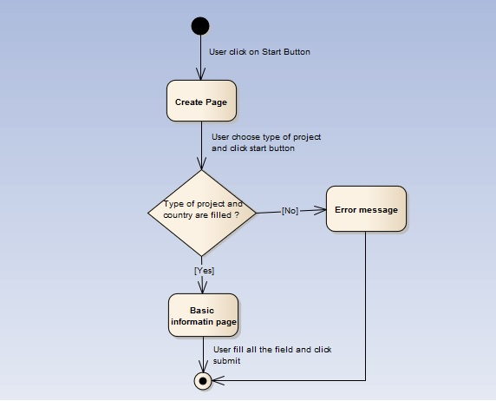

Figure 1‑10: Create a project workflow

Brief description: Member can use this function. Steps:

* Step 1: User click on start button.
* Step 2: System return Create page.
* Step 3: User choose type and country then click start.
* Step 4: System return Basic page.
* Step 5: User fill all the fields then click submit.
* Step 6: System return Backer information page.

#### Remind a project workflow

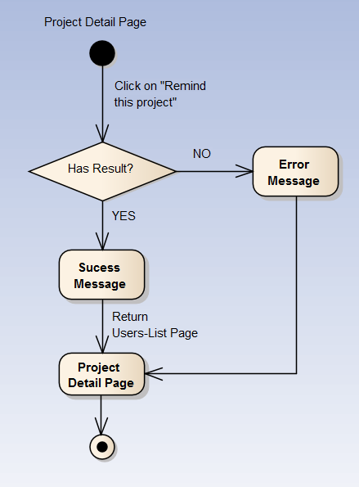

Figure 1‑11: Remind a project workflow

Brief description: Member can use this function. Steps:

* Step 1: User click on “Remind this project” button.
* Step 2: System return success message or error message.
* Step 3: System return Project Detail page.

#### Report a project workflow

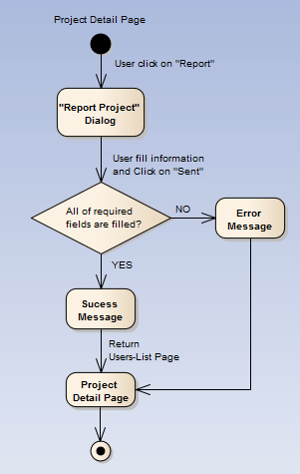

Figure 1‑12: Report a project workflow

Brief description: Member can use this function. Steps:

* Step 1: User click on report button.
* Step 2: System return “Report project” dialog.
* Step 3: User fill information and click “Sent”
* Step 4: System return success message or error message.
* Step 5: System return project detail page.

### Product Features

These are the features of First Aid system:

#### First Aid Application features

* **List of injuries:** List of common injuries will be displayed in main screen when user launch in First Aid application
* **Instruction steps of injury:** Instructions steps first aid of an injury will be shown when user tap on an injury’s name.
* **Searching:** Users search the related keywords of injury and results will be displayed in the screen.
* **Reading steps of instructions:** Read steps of instructions for users. Users can perform first aid and listen to steps of instructions at the same time.
* **Call 115:** This feature will help users to call 115. In an emergency that need to call 115, this feature can send to operator the user information including phone numbers and coordinates.
* **Current location:** Users can get their exact location via the map. In case there is no exact address, the users can get the nearest locations.
* **Finding nearby health facilities:** Users can find list of the nearest health facilities and see address, distance, phone number, and directions to the health facilities.
* **Learning:** Information about instructions of each injury will be explained more clearly than the instruction steps first aid in emergency screen. This feature will help users to have more knowledge about first aid in injury situations.
* **FAQs:** Users can see FAQs about an injury and send questions about injuries
* **More:** This feature is a collection of some other popular features for users:

**-** Send feedback

**-** View first aid course

**-** Sharing

#### Ambulance Application features

* **Login/Logout:** Ambulance staff need to login to use the account. The staff account can be given by administrator.
* **Notify task:** Ambulance staff can receive the task automatically from the coordinator without making a phone call or using walkie-talkie like traditional way.
* **Location of caller:** Ambulance staff will determine the caller’s location exactly and know the shortest way from the location of ambulance to the location of caller.
* **Report to Dispatcher:** Ambulance can report to dispatcher after picking up victim to hospital.
* **Status:** Ambulance will report to dispatcher about the ambulance status of implementing task or not.

#### Dispatcher Application features

* **Login/Logout:** Dispatcher need to login to use the account. Dispatcher’s account is given by administrator.
* **Dispatch ambulance:** Dispatcher receives information from users including their status and their coordinates, then dispatcher will dispatch the ambulance to the victim’s location. The system will automatically choose the nearest available ambulance.
* **Show direction from ambulance to caller:** dispatcher will know the nearest way from ambulance’s location to victim’s location and follow ambulance’s moving.
* **View ambulance information:** Dispatcher can know about the available of ambulance
* **Cancel emergency case:** In case the victim doesn’t need ambulance, dispatcher can cancel task.

#### Admin/Expert Application features

* **User management:** Admin can create new account for dispatcher, ambulance staff and health expert, update, delete and search account.
* **Data Management:** Medical expert can delete, update, or add new information about first aid.
* **Users’ questions management:** Admin and expert will receive notifications when there are comments or questions from users and answer them.

### User characteristic

FAS has five objective users:

* + **FAA user:** Users uses First Aid application in android mobile.
  + **Dispatcher:** Users are offered an account by admin to use Dispatcher website.
  + **Ambulance staff:** Users are offered an account by admin to use Ambulance application in tablet.
  + **Expert:** Users are offered an account by admin to use First Aid website, they can manage all information about first aid and learning of emergencies, answer the question of FAA users.
  + **Admin:** They can manage all information about all user types, answer the question of FAA users.

## Functional Requirements

### First Aid

**Access right: First Aid application user**

This function related to emergency situations, support to user can first aid injuries. FAA user can view list of injuries, view instruction steps of an injury, search injuries, read instruction steps.

### Learning

**Access right: First Aid application user**

This function is used to learn about first aid methods clearly. FAA user can view detail explain about first aid an injury. Beside, user can view FAQs about an injury.

### Location

**Access right: First Aid application user**, **Ambulance staff**

This function is used to view the current location of user. Beside, FAA user can view list of nearest health facilities and view direction to a health facility. Ambulance staff can view location of caller or victim, view direction to them.

### Call

**Access right: First Aid application user**

This function is used to call to 115 emergency center and other health facilities when user needs help from them. If user calls to Dispatcher application of 115 center, they can send their coordinates and phone number to 115 center and that help the emergency happen fast and easily.

### Send question

**Access right: First Aid application user**

This function is used to send questions about issues related to first aid, injuries case and medical expert will answer your question. Beside, user can send feedback about function of application to admin.

### Common

**Access right: Ambulance staff, dispatcher, expert and admin**

This function is used to login, logout. Ambulance staff login to Ambulance application, dispatcher login to Dispatcher application and expert or admin login to administrator website, and they can do their work.

### Task

**Access right: Ambulance staff**

This function related to the task of an ambulance. Ambulance staff can receive emergency task to dispatcher, report when they picked up caller, report when they complete task or report when ambulance car have problem.

### Dispatch

**Access right: Dispatcher**

This function related to the jobs of a dispatcher. Dispatcher can receive emergency call to FAA user and has information from users including their status and their coordinates then dispatcher will dispatch the ambulance to the caller’s location.

### Manage user's account

**Access right: Admin**

This function is used to manage user’s account. Admin can create a new dispatcher or ambulance staff or expert’s account, update, delete them.

### Manage Q&A

**Access right: Admin and expert**

This function is used to manage user’s Q&A. Admin will answer user’s feedbacks about function, GUI or something related to application. Expert will answer questions about injuries and first aid.

### Manage injury

**Access right: Expert**

This function is used to manage information about first aid and injuries situation. Expert can delete, update, or add new information about first aid.

## Non-functional Requirement

The system has to satisfy these principles:

* **Learnable**: The user interface must be easy to learn, even at the first time looking at the screen, user may immediately understand the function of each button or icon.
* **Efficiency**: The user interface must minimize the number of steps that the system takes to complete its task.
* **Memorable**: System contains some complex screens. Therefore, interface should be easier to use each time the user interacts with it.
* **Visibility**: Important information (example: text in nodes) should be clearly visible.
* **Consistency**: Like items should always be displayed and act the same way through the entire application.
* **Easy to maintain and upgrade**
* **Ensure data security capabilities, high performance**
* **Scalability system**